**Business Problem**

In the last few years, City hotel and Resort Hotel have seen an increase in the cancellation rates. Each hotel is dealing with a few issues like lower revenue and not maximum utilization of the hotel rooms. Consequently, lowering the cancellation rates is the top priority for both hotels to increase their efficiency in generating revenue.

The analysis of this dataset – factors like hotel booking cancellations and yearly revenue generation and how to improve are the focus of this report.

**Assumptions**

* No unusual occurrences between 2015 and 2017 will have a significant impact on the data used
* The information is still current and can be used to analyze a hotel’s possible plans in an efficient manner
* The hotels are not using any of the advised solutions
* The biggest factor affecting the effectiveness of revenue generation is booking cancellations
* Cancellations result in vacant rooms for the booked length of time
* Clients make hotel reservations the same year they make cancellations

**Research Questions**

1. What are the variables affecting the number of cancellations?
2. How can we reduce the number of cancellations?
3. How will hotels be assisted in making pricing and promotional decisions?

**Hypothesis**

1. When the prices are higher, number of cancellations are higher
2. When there is a long waiting list, customers tend to cancel more frequently
3. The majority of clients are coming from offline travel agents to make their reservations

**About the dataset**

* The dataset ‘Hotel Booking’ has been taken from Kaggle and is in a csv format
* The dataset contains around 32 columns and 119390 rows

**Analysis and Findings**

The above bar graph shows the percentage of reservations that are cancelled and not cancelled. Almost 37% of the clients cancel their reservations, which is a concerning number.

In comparison to Resort hotels, City hotels have a larger number of bookings. This may be due to prices of resort hotels being higher.

The above line graph shows that, on most days, the average daily rate for a city hotel is less than that of a resort hotel. Weekends and holidays see a rise in the prices of both city and resort hotels, but in comparison, the prices of resort hotels tend to go up much higher.

The above bar graph has been developed to analyze the months with the highest and lowest reservations levels according to reservations status. Evidently, the number of confirmed reservations is highest in August. Whereas, in January almost an equal number of confirmed A graph of different colored bars
reservations and cancelled reservations occur.

The above bar graph demonstrates that cancellations are most common when prices are greater. Therefore, the cost of the accommodation is a major factor in cancellations.

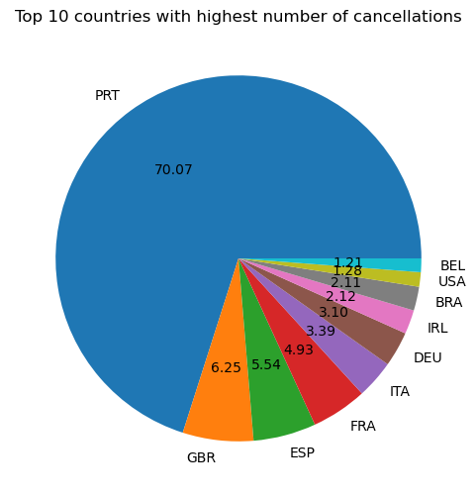

Portugal has the highest number of cancellations. This could be due to the poor quality of services being offered in the hotels, the standards of hotels not being up to customer’s satisfaction or high prices compared to quality of services.

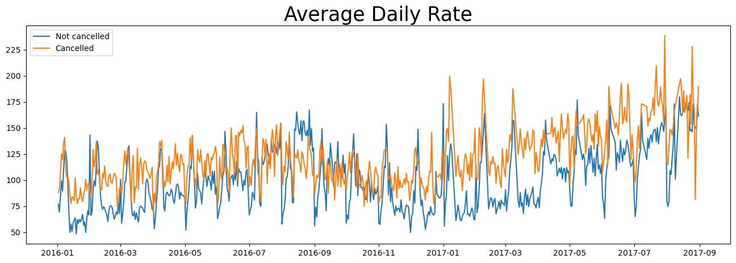We can see that around 47% of the clients are coming through online travel agents, 18% from offline travel agents, 27% comes from groups and a meagre 4% book hotels directly by visiting the premises.

As evident from the above graph, cancellations are higher when the average daily rate is higher than when it is not cancelled. It clearly proves our analysis that a higher price leads to a larger number of cancellations.

**Suggestions**

1. Higher prices lead to a rise in the cancellation rates. To reduce the number of cancellations, hotels could work on creating better pricing strategies and offer discounts for hotels based on specific locations.
2. As the ratio of cancellations to confirmed reservations of Resort Hotels are higher , so they should provide discounts during weekends and holidays
3. In January, hotels can start campaigns or marketing with a reasonable amount to increase their revenue as the cancellation is highest in this month
4. In Portugal, they could increase the quality of their hotels, services offered to reduce the cancellation rate